Colorado Hack-a-Thon  
February 22nd and 23rd

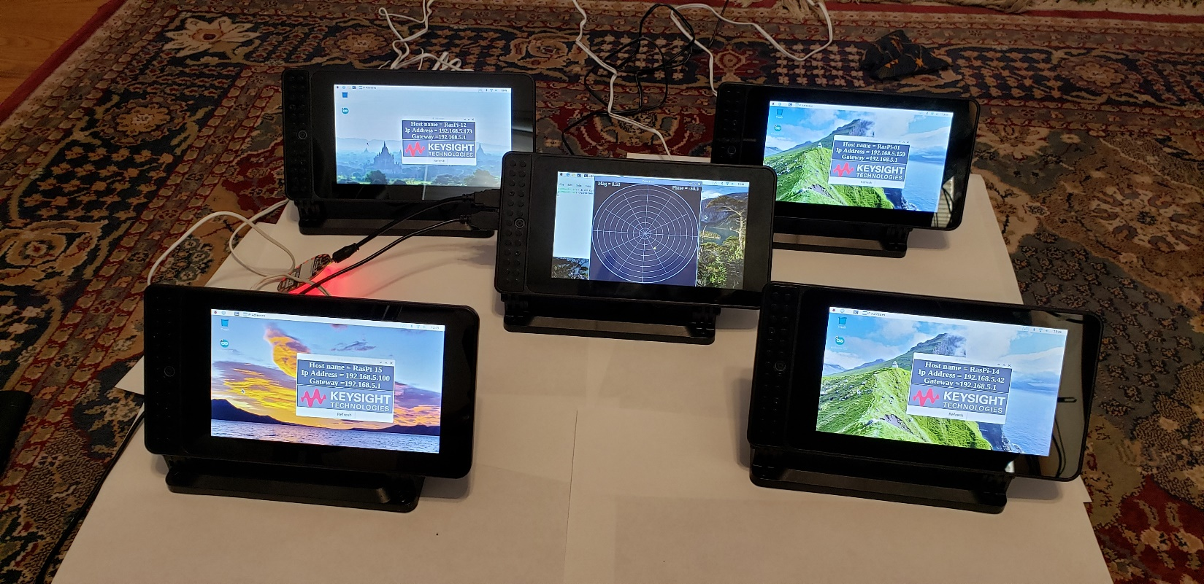

KHP

Keysight Hacking Platform

KHP

Raspberry Pi + Smarti-Pi Case  
Standard kit and Circuit explorer kit.

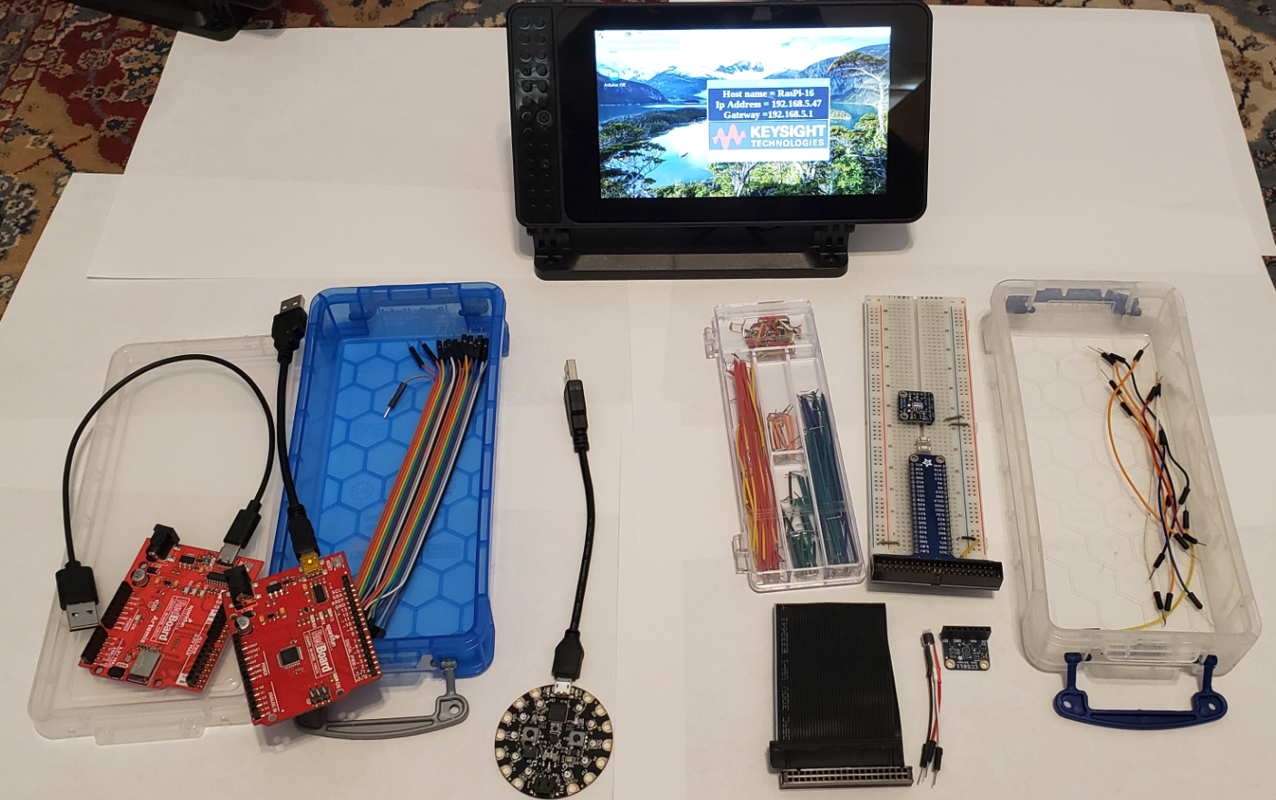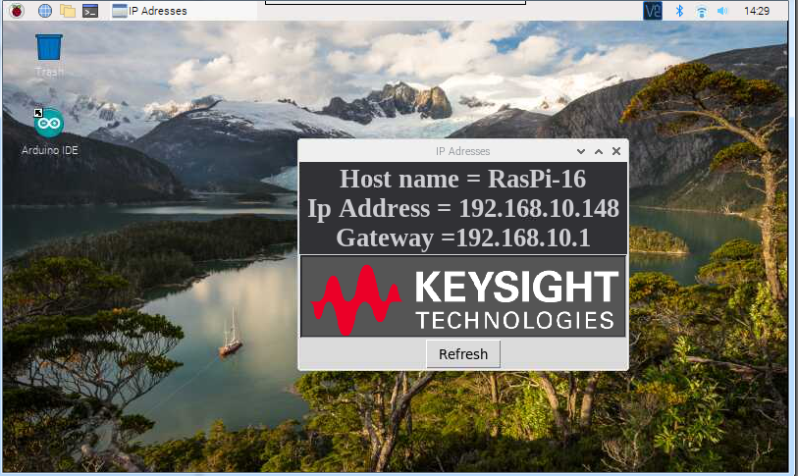

Circuit Explorer Kit

Proto-board wire kit

Pi to Protoboard adapter

MLP3115A – I2C pressure sensor

CSC811 – Air Quality Sensor

TMP36 – Analog Temperature

2 buttons

Standard Kit

Circuit Playground

SparkFun Redboard

SparkFun Artemis

20 wire bundle Male-Male

Basic Tour of the Raspberry Pi

Wireless Access Point

**SSID: PiNet Passkey: PiNet3295**

On power up:

This will show the Host name and IP address once it is connected to a network. This can be closed at any time

Tour open terminal

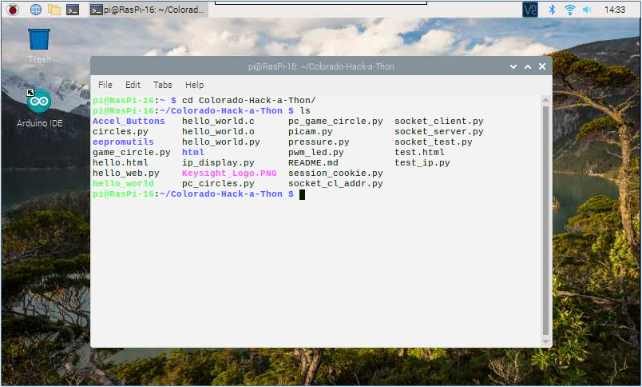

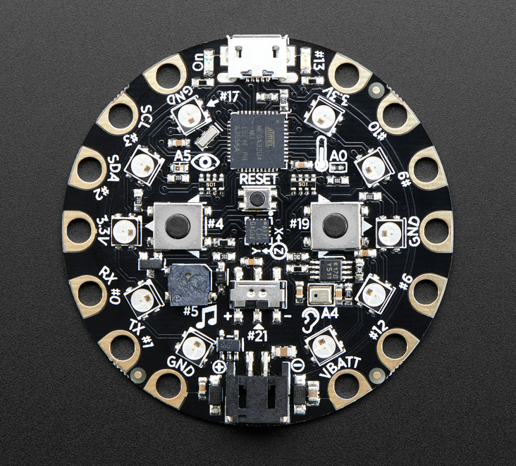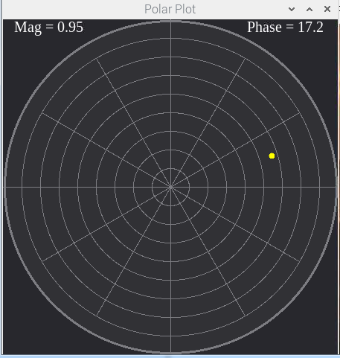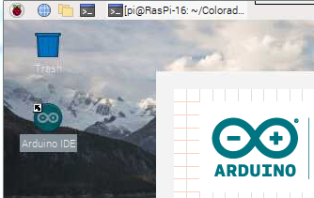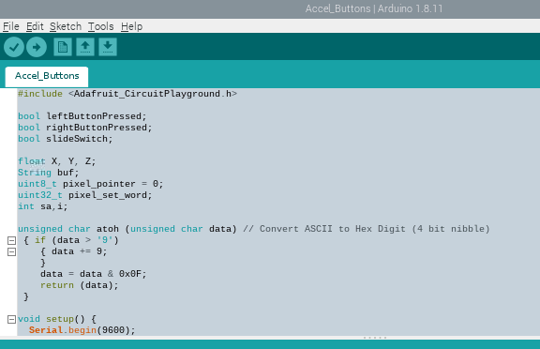

Change directory to the Colorado-Hack-a-Thon folder

Type: **python picam.py**  - The camera should start up

Plug in the round circuit board, “Circuit Playground” to a USB port. Then type: **python game_circle.py** Notice what happens when the marker gets to the center.

Look at Arduino Programming

**Close the game_circle program if running.**

Double click the Arduino IDE on the desktop.

This is the program loaded into the Circuit Playground

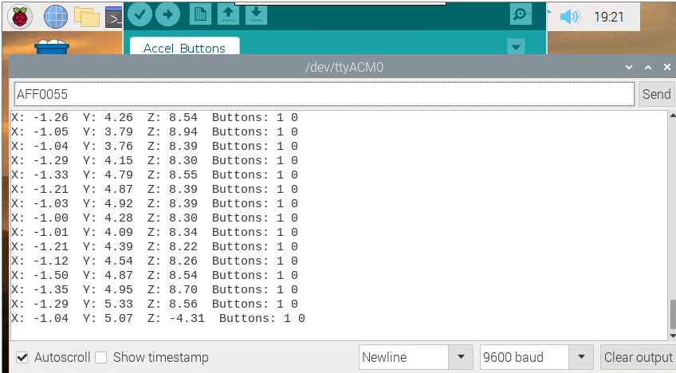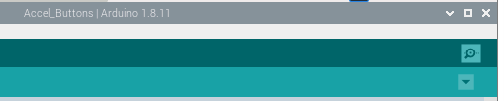

Enter LED# + RGB code

Look at serial monitor

Click to open monitor

Serial data coming to the Pi

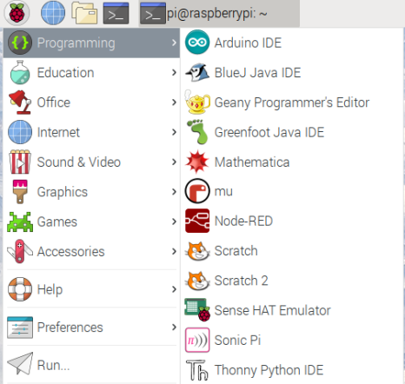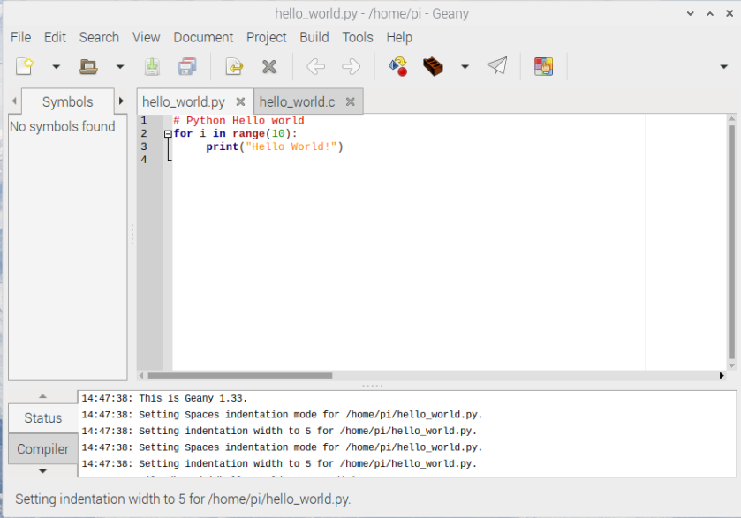

Change the code, save and run it.

Geany – A Raspberry Pi IDE

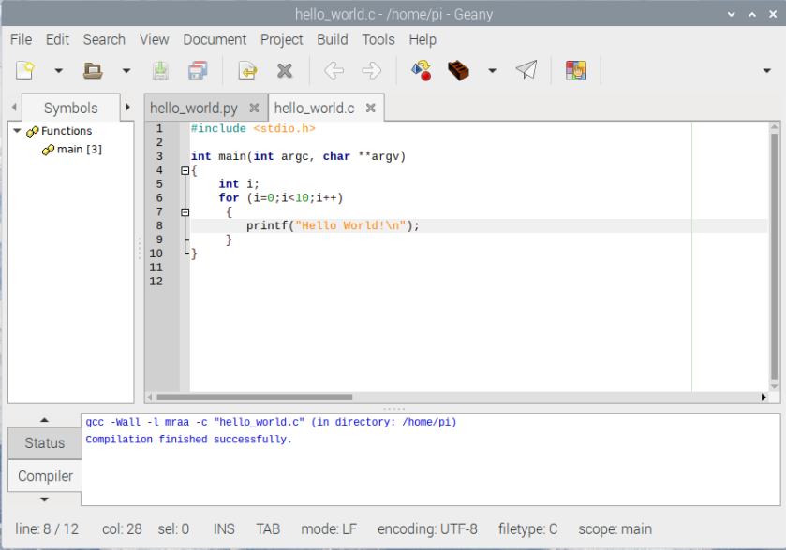

* The i2c bus is a bidirectional bus with 2 lines SDA and SCL.
* This bus can have up to 117 devices.
* i2cdetect - Show the devices on an i2c bus
* i2cget – read a register value from an i2c device
* i2cset – write a value to an i2cdevice.
* i2cdump – dump all the values available from an i2cdevice.

Handy Tools I2C

Geany and C programming

Then Run it

Compile the code

Build the code

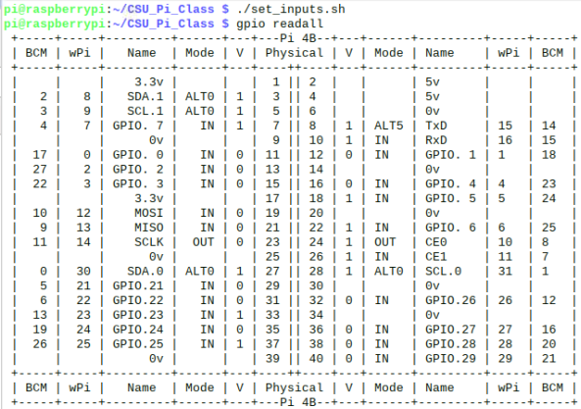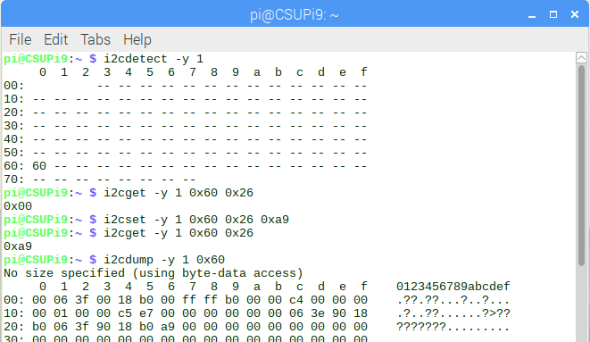

In a terminal in the Colorado-Hack-a-Thon folder

Type **./set_inputs**

**gpio readall**

Handy Tools GPIO

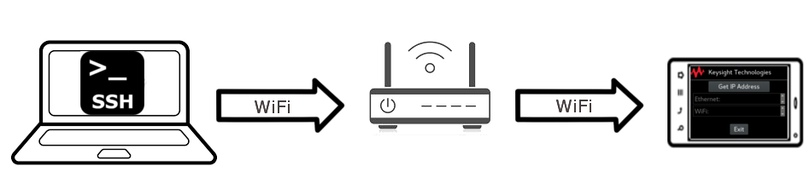

Overview

This section gives an brief overview of the hardware in the Keysight Hacking Platform (KHP), how to connect the the KHP over SSH, and where to find the example programs.

The KHP consists of:

* + Raspberry Pi 3 with 7" capacitive touch screen in SmartiPi-2 Case
  + Raspbian Linux image with some example programs pre-loaded.
  + Some additional hardware to hack with (Arduino, Circuit Playground and other devices)

The general workflow for using the KHP consists of connecting to it over Secure Shell (SSH) and transferring files using Session Control Protocol (SCP). 

Connecting the Raspberry Pi with PC or MAC



Connecting to the Raspberry Pi Over SSH

The Raspberry Pi will take approximately a minute to boot up after plugging it in. After fulling booting up

the Raspberry Pi will automatically start the Keysight IP Finder application. Click the Refresh button to show the configured IP addresses for the Ethernet and WiFi interfaces. Depending on how quickly the interface receives an IP address you may have to click the button a few times.

Write down the IP address of the interface you would like to use. We are now going to use this IP address to connect to the Raspberry Pi over SSH. Follow the instructions for the operating system running on your computer:

SSH Login Credentials

## Set Up WinSCP

1. For Windows users, download and install a copy of WinSCP from <https://winscp.net/eng/download.php>. You should see a WinSCP icon on your desktop.
2. Double-click to launch WinWCP and click “New Site”. Then, configure the new site with the following settings.

|  |  |
| --- | --- |
| **File Protocol** | SCP |
| **Host name** | 192.168.5.xxx |
| **Port Number** | 22 |
| **Username** | pi |
| **Password** | Channel1 |

## Copy Files with WinSCP

A GUI should open where files can be dragged across from the PC to the Raspberry Pi and Visa-Versa.

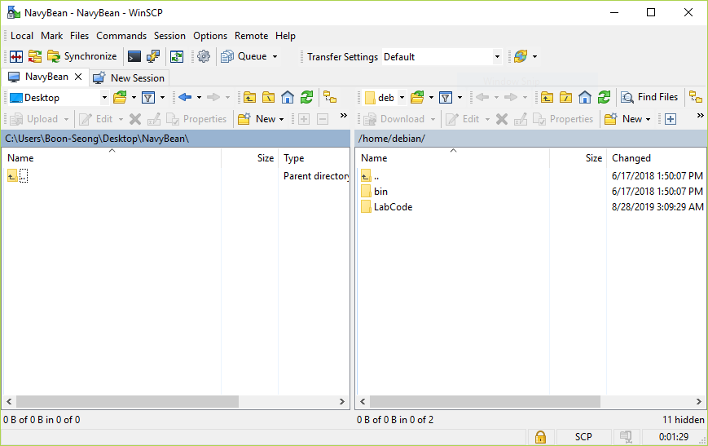

PC

Raspberry Pi

1. On your desktop, create a text file “test.txt”.

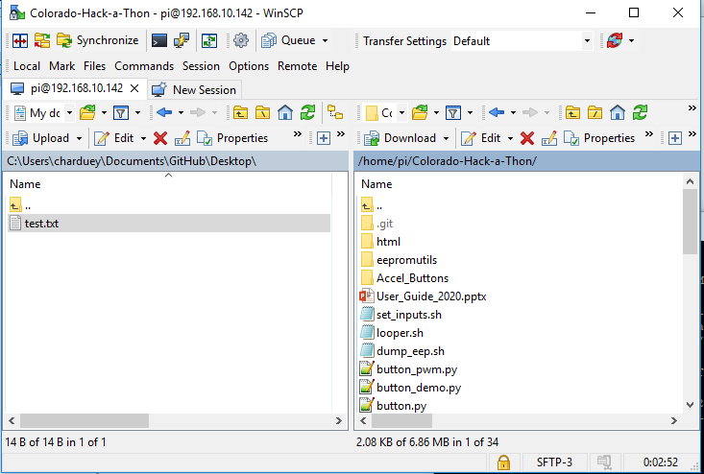

Drag the text.txt file across in WinSCP to copy it over to the Raspberry Pi.



**Drag the file across**



|  |
| --- |
| **NOTE**  For Linux based systems, copy the file using **scp M1-L1.zip** [pi**@192.168.7.2**](mailto:pi@192.168.7.2) command. |

## Edit Files with WinSCP

1. With the copy of the test.txt file in BeagleBone, right-click the file and click **Edit**..

It should prompt a built-in text editor where you will use it to edit shell scripts with a GUI text editor from PC.

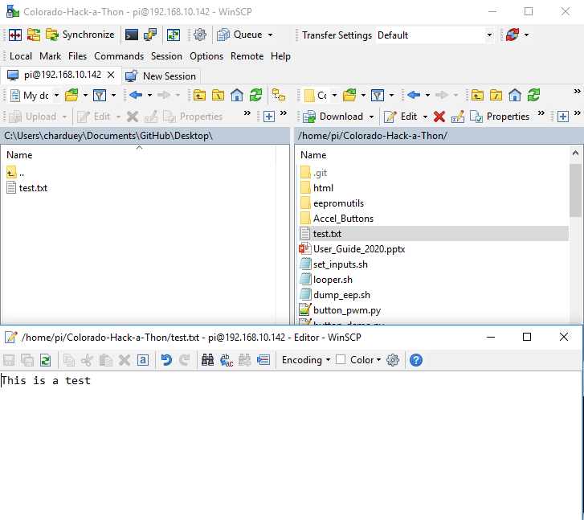

## Putty Communications

## Establishing Console Communications between Pi and PC via WiFi

1. If not already done so, download and install PuTTY from <http://www.putty.org/>

Choose 32-bit or 64-bit, whichever is compatible with your operating system.

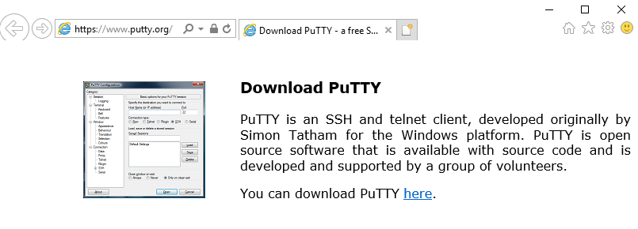

1. A PuTTY Configuration window will pop up to determine the connection type. Select **SSH** for Connection type and enter **192.168.5.xxx** for the **IP address**.

If this is the first time that the computer is connecting to this Beagle Bone, you will receive this message and question to which you should click **Yes**:

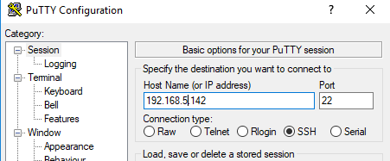

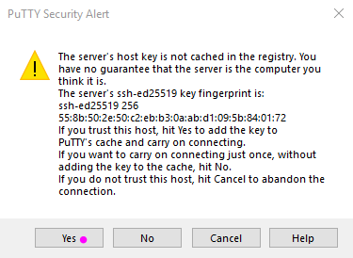

1. Click **Open** to open the terminal window. Press **Enter** on the PC keyboard to check and verify connectivity.

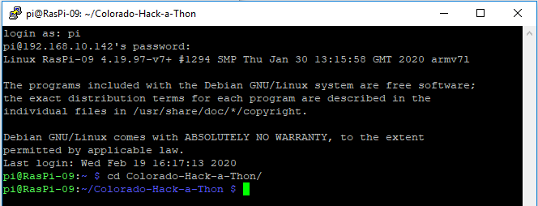

Default username : pi

Default password : Channel1

## Mac OS X

With Mac OS X there are a few deferent ways that you can go about using SCP with the Raspberry Pi.

You can either use the SCP utility from the command line for transferring or you can download and

install MacFusion to allow you to browse the Raspberry Pi's system through Finder.

The general usage for the SCP command is: scp source file destination file

## MAC Transferring a Single File to the Raspberry Pi

1.) Open a terminal.

2.) Run this command: scp {file to transfer} pi@{IP Address of Pi}:{ Location to transfer file to}

MAC Transferring a Single File from the Raspberry Pi

1.) Open a terminal.

2.) Run this command: scp pi@{IP Address of Pi}:{ Location of file to transfer}: {location to save file}

# Linux

With Linux there are a few deferent ways that you can go about using SCP with the Raspberry Pi. You

can either use the SCP utility from the command line for transferring or several browsers in Linux

natively support mounting a SSH system with SCP. For most common browsers the option to mount

the remote system is usually under the File -> Connect to Server... menu option.

The general usage for the SCP command is: scp {source file} {destination file}

Transferring a Single File to the Raspberry Pi

1.) Open a terminal.

2.) Run this command: scp {file to transfer} pi@fIP Address of Pi}:{Location to transfer file to}

Transferring a Single File from the Raspberry Pi

1.) Open a terminal.

2.) Run this command: scp pi@{IP Address of Pi}:{Location of file to transfer} {location to save file}